Walk 43 Ragg Stone and Chase End Hills
Last walked in November 2016

Description. 7 km (4.3 miles). The final undulations of the Malvern Hills manifest themselves as Ragged Stone and Chase End Hills. Lower than, and detached from, the main ridge, they tend to be less well trodden, and this adds to their quiet charms. Attractive at any time of year, but especially in autumn, this short walk can form an absorbing introduction to the southern Malvern’s.
Start. Hollybush (A438) Explorer Map 190. Grid 759369.
Directions from Whitecross Roundabout (Turn milometer to zero). Take the A4110 Canon Pyne (Three Elms road) for 1 mile and TR at the traffic lights onto the A4103 Worcester (Roman road). After 7.7 miles TR, signposted to Stoke Edith. After 9 miles TL at road junction (not sign posted) onto main road to Ledbury. Reach roundabout at 15.9 miles and go straight across heading for the Town Centre. Go thru town centre and TL at traffic lights onto the A449 to Malvern and Worcester (total 17 miles). After 1 mile LR onto the A438 to Eastnor and Tewkesbury (total 18 miles). After 2.9 miles just past the Hollybush signpost, on the L is a car parking area with a Countryside Information Board in it (total 21 miles).

1. Car Park. Walk down the road from the car park, in the direction of Tewkesbury for about 250m. Shortly before the telephone kiosk take a track to the R, which curves to the L as it goes past the old Post Office and gains height. Immediately after going thru a wooden gate, TR up a small track which heads directly (and hence quite steeply) to one of the twin summits of Ragged Stone Hill.

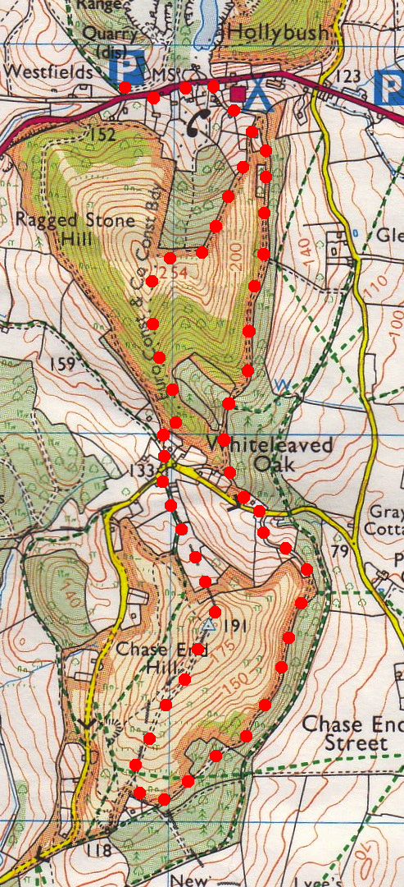
2. Ragged Stone Hill. When you get to the end of the wood on your R, ignore the hill top straight ahead and follow the edge of the wood around to the R, the track descends very slightly then rises and bears L away from the wood and up to Ragged Stone Hill top. I suppose I should have warned you that the hill is cursed. Apparently a monk at nearby Little Malvern Priory lapsed in his vow of chastity, and as a penance had to climb Ragged Stone Hill each day on his hands and knees. He was supposed to pray when he reached the summit, but one day instead he cursed the hill and all upon whom its shadow should fall. Victims are said to include Cardinal Wolsey and William Huskisson MP - the latter killed in an accident whilst Stephensons Rocket was being tested. Still, it's too late to worry about such things now. Admire the views over the Severn Vale, with Bredon Hill prominent and then traverse to the higher summit at 833ft. Views open out to the west with Eastnor Castle especially prominent when clothed in its fiery autumnal mantle of Virginia Creeper. Now descend the ridge for about ½ km along a small rocky path (keep to the path on the L) and thru a wooded area until near the bottom you reach a track junction next to a small part of a rocky wall initialled ‘The Ragged Stone’. TR, (heading towards the wooden gate), the track bends around to the R, you pass Elsies Cottage (L) and continue on down thru a wooden gate and onto a tarmac road. This is Whiteleaved Oak - a lovely name for a delectable cluster of original and restored dwellings in one of the most tranquil spots imaginable. The hamlet straddles the boundaries of the Three Counties - Worcestershire, Gloucestershire and Herefordshire. TR along the road and immediately after the road bends L TL along a public footpath (not for horses). A little way along this track you pass Cider Mill Cottage on your L. Continue up hill along a muddy enclosed track that goes thru a small wooden gate and further on you have a stiff little climb to get to the triangulation column at the summit of Chase End Hill (once known as Gloucestershire Beacon).
1

3. Triangulation Point. At a height of 626ft the views are particularly open to the south, to the Cotswolds, May Hill (an upturned pudding bowl with a clump of trees on the top) and on a clear day a glimpse of the Severn Estuary. TR and continue along the ridge, descending to the edge of a wood on your L. TL along a grassy track heading into the woods and keep to the L of a wire fence. Keep the wire fence to your R as you go thru the lightly wooded area for over ½ km along a dirt track to reach a tarmac road, you pass thru three wooden gates. When you reach the road (a house and bridge is on the R hand side) you TL.
2

4. 50m Walk. After about 50m along the road, TR at a small gap in the wood, (opposite a wooden gate). Take the track that goes off to the R and then bends around to the L to meet up with the broken down wall. Follow the wall up hill a short distance to cross a stile and emerge once more at the start of ‘The Ragged Stone’ hill. Bear R, ignore the track on the L that goes uphill and take the pleasant woodland track along level ground for about a km to return you to the A438 road, ignoring a track off to the L and a wooden gated way marked public footpath on the R. When you reach the road TL and head uphill to the car park on the R.
3
4

